From Social Force Model-Based Pedestrian Simulation to AI-Based Prediction: Density Heatmap Generation with Pix2PixHD and CVAE

Detthana Pattaphat
Chulalongkorn University
6872011825@student.chula.ac.th

Abstract
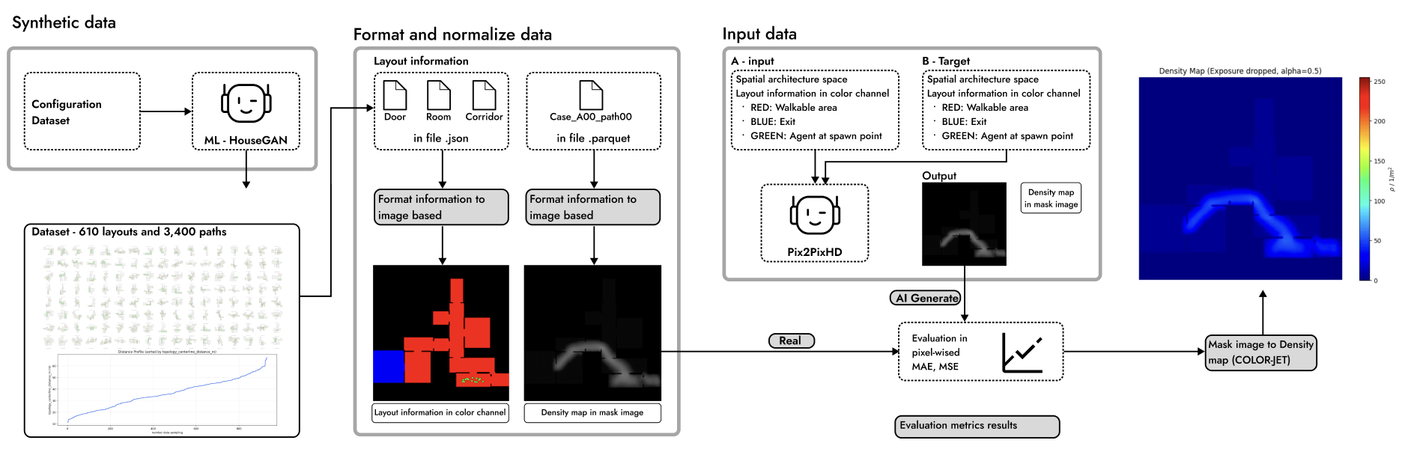
Figure 1 Research framework
Pedestrian simulation is widely used in architectural design and development to evaluate movement patterns, crowd distribution, and spatial performance. Conventional pedestrian simulation methods often rely on physics-based models, among which the Social Force Model is one of the most widely recognised and adopted approaches in both academic research and professional simulation software. However, these methods can be computationally demanding in terms of processing time and resources, making them less suitable for early-stage architectural design exploration, where multiple design alternatives must be evaluated rapidly.
This research proposes the use of Artificial Intelligence (AI) as a surrogate model to approximate the visual outputs of conventional pedestrian simulation. Specifically, the study focuses on generating pedestrian density heatmaps for architectural space. The objective is to develop a generative model capable of predicting density distribution patterns from architectural floor plan information: point of origin, destination points, and varying numbers of occupants. The training data were synthetically generated using JuPedSim, a commercial Social Force Model-based pedestrian simulations.
The methodology involved generating a dataset comprising 600 architectural layouts and 3,400 simulated scenarios, with variations in spatial layout, origin–destination conditions, occupant density, and movement patterns. All scenarios were constrained to a single-destination movement task and operated at the operational layer of pedestrian simulation. The dataset was then used to train Pix2PixHD and Conditional Variational Autoencoder (CVAE) models to learn the relationship between architectural spatial configuration, origin-destination conditions, agent quantity, and resulting pedestrian density distributions. Input information, including spatial layout, start and exit locations, and classified occupant numbers, was encoded as multi-channel image data. Model performance was evaluated using pixel-based Mean Absolute Error (MAE) and Mean Squared Error (MSE).
The results demonstrate that the proposed learning-based surrogate models can generate pedestrian density heatmaps within an acceptable margin of error. Among the tested models, Pix2PixHD showed the strongest potential, particularly in preserving image resolution and maintaining spatial details such as walls, boundaries, and non-walkable areas more effectively than the other trained models. The generated outputs successfully capture spatial distribution patterns of pedestrian movement across varying floor plan configurations. These findings suggest that AI-based surrogate modelling offers a promising approach for supporting rapid visual feedback in early-stage architectural design exploration. Further investigation is required to improve spatial accuracy, evaluate perceptual similarity, and assess the applicability of the method in professional design workflows.

Keyword:
Pedestrian simulation;
AI-based simulation.
density heatmap;
surrogate model;
Pix2PixHD;
Conditional Variational Autoencoder (CVAE);

References
Pedestrian simulation:

Social Force model:
Helbing, D., & Molnár, P. (1995). Social force model for pedestrian dynamics. Physical Review E, 51(5), 4282–4286. https://doi.org/10.1103/PhysRevE.51.4282

Density Heatmap:
Tan, C., & Zhong, X. (2023). A rapid wind velocity prediction method in built environment based on CycleGAN model. In P. F. Yuan, H. Chai, Y. Yan, & P. Wang (Eds.), Hybrid Intelligence, Computational Design and Robotic Fabrication (pp. 253–262). Springer. https://doi.org/10.1007/978-981-19-8637-6_22

Pix2PixHD:
Wang, T., Liu, M., Zhu, J., Tao, A., Kautz, J., & Catanzaro, B. (2017). High-Resolution Image Synthesis and Semantic Manipulation with Conditional GANs. 2018 IEEE/CVF Conference on Computer Vision and Pattern Recognition, 8798-8807.

Conditional Variational Autoencoder (CVAE):
Kingma, D.P., & Welling, M. (2013). Auto-Encoding Variational Bayes. CoRR, abs/1312.6114.

Mean Absolute Error (MAE):

Mean Squared Error (MSE):

